

PROJEKT SONDA

TOPIC: TECHNICAL DOCUMENTATION
FOR STUDENTS OF BUILDING INDUSTRY


Střední odborná škola a Střední odborné učiliště,
Vocelova 1338, 500 02 Hradec Králové
Vocelova 1338, 500 02 Hradec Králové, tel: 495212861, fax: 495212770, http: www.sosasou-vocelova.cz

CONTENTS:

Technical documentation and drawings – HEAT PUMP 2
☺Discuss: 2
☼ Learn: 2
☻ Solve 4
♣ Read: Why to buy or not to buy a heat pump? 6
Technical documentation and drawings – HEAT PUMP – User guide 7
☺Discuss: 7
☼ Learn: 7
♣ Read: Warranty Term and Conditions 9
☻ Solve: 10
Technical documentation and drawings – HEAT PUMP – DRAWINGS 11
☺Discuss: 11
☼ Learn: 12
☻ Solve: 12
Resources: 14

Technical documentation and drawings – HEAT PUMP

☺Discuss:

What is the geothermal energy?

What is a heat pump?

What kinds of heat pumps do you know?

How do geothermal heating systems work?

☼ Learn:

Geothermal energy
- The word geothermal comes from the Greek words geo (earth) and therme (heat). So, geothermal energy is heat from within the Earth. We can recover this heat as steam or hot water and use it to heat buildings or generate electricity.
- Geothermal energy is a renewable energy source because the heat is continuously produced inside the Earth.
- Geothermal energy is generated in the Earth's core. Temperatures hotter than the sun's surface are continuously produced inside the Earth by the slow decay of radioactive particles, a process that happens in all rocks

Heat pump

- Heat pump is a device that uses a small amount of energy to move heat from one location to another.
- Heat pumps are typically used to pull heat out of the air or ground to heat a home or office building, but they can be reversed to cool a building. In a way, if you know how an air conditioner works.
- Heat pumps also work extremely efficiently, because they simply transfer heat, rather than burn fuel to create it.

The main variants in common use are:
- Air to Water
- Ground to Water
- Ground to Air

The heat pump consists of:
- Evaporator ( takes the environmental heat)
- Compressor ( compresses the coolant)
- Expansion valve ( draws the coolant off)
- Condenser ( transfers the heat into the water)

☻ Solve
PUT THE PARAGRAPHS IN THE CORRECT ORDER:
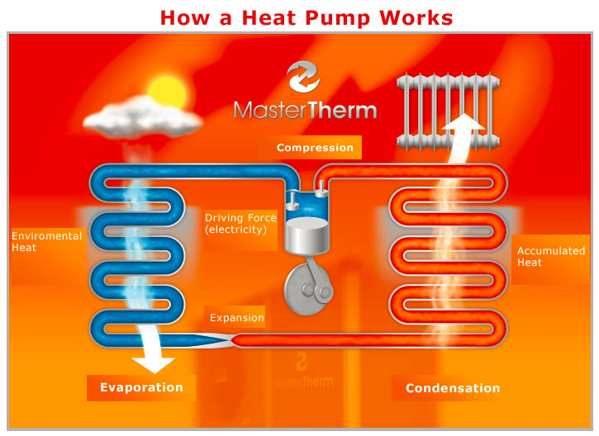
Condensation: Using a second heat exchanger, the heat from the heated coolant is transferred to the water circulating through the radiators. This causes the coolant to drop in temperature and condense back into a liquid state. The radiators distribute the heat provided into the heated areas. The chilled water in the heat loop then travels back into the second heat exchanger, where it is heated again.
This cycle keeps repeating itself over and over again.
Evaporation: The coolant circulating in the heat pump system collects heat from the air, water or the ground and this process causes the coolant to evaporate and change to a gaseous state.
Compression: The heat pump's compressor rapidly compresses the coolant, which is now in a gaseous state and several degrees warmer. Thanks to the laws of physics behind the compression process, which cause the temperature of the compression medium with increases in pressure, the compression elevates the otherwise low potential heat of the coolant to a higher level – approximately 80°C.
Expansion: By passing through the expansion valve, the coolant travels back to the first heat exchanger, where it is once again heated.
STEP 1:
STEP 2:
STEP 3:
STEP 4:
STEP 5:
MATCH THE STEPS WITH THE CZECH TRANSLATION AND TRANSLATE THE STEPS IN CZECH:
Tento koloběh se neustále opakuje.
Takto zahřáté chladivo pomocí druhého výměníku předá teplo vodě v radiátorech, ochladí se a zkondenzuje. Radiátory toto teplo vyzáří do místnosti. Ochlazená voda v topném okruhu pak putuje nazpět k druhému výměníku pro další ohřátí.
Od vzduchu, vody nebo země odebírá teplo chladivo kolující v tepelném čerpadle a tím se odpařuje (mění skupenství na plynné).
Kompresor tepelného čerpadla prudce stlačí o několik stupňů ohřáté plynné chladivo, a díky fyzikálnímu principu komprese, kdy při vyšším tlaku stoupá teplota, jako teplotní výtah "vynese" ono nízko-potenciální teplo na vyšší teplotní hladinu cca. 80°C.
Průchodem přes expanzní ventil putuje chladivo nazpátek k prvnímu výměníku, kde se opět ohřeje.

KROK 1:
KROK 2:
KROK 3:
KROK 4:
KROK 5:

♣ Read: Why to buy or not to buy a heat pump?
PUT THE TITLE „ADVANTAGES“ AND „DISADVANTAGES“ TO THE RIGHT PARAGRAPHS.
MAKE YOUR OWN CONCLUSION.
For heating the home, heat pumps are definitely one of the most efficient systems available. Heating your home this way means lower power bills as you are saving energy. Heating through furnaces brings a 'dry air feel' to the home, so people use humidifiers to correct this.
With electric heat pumps you do not need a humidifier. They also run far quieter than other heating systems because the compressor is placed outside of the home or building. Some people find the cost both an advantage and disadvantage with a heat pump. It depends how you look at it, as the huge savings on energy and bills counter-balance the price.
Geothermal heat pumps are high priced, but also bring the biggest savings. The fuel and electricity efficiency is the biggest advantage. The heating is not produced through fossil fuels or electricity, thus making this system eco-friendly as well as cost saving. These systems are most suited to temperate climates as below freezing temperatures can bring disadvantages.
For a large percentage of people the initial cash outlay is a great disadvantage as it is expensive when you have to purchase and install heat pumps for the first time. Over time though, the cost-savings it brings will even out the initial expense. In intemperate regions of the USA where winter temperatures go below freezing point regularly, this form of heating can bring another initial cash outlay that makes it very expensive. You will have to look into getting a second unit as a back-up to be able to bring heating to the entire home or building.

YOUR CONCLUSION AND OPINION:
I would buy or recommend a heat pump because…….
I would never buy or recommend a heat pump because…….

Technical documentation and drawings – HEAT PUMP – User guide

☺Discuss:

What is technical documentation?

What is a manual?

Why do we need manuals?

Which information do we find there?

☼ Learn:

Technical documentation
= refers to any type of documentation that describes handling, functionality, construction and use of a technical product
Documentation may include:
- Warranty terms and conditions
- Assembly manual
- User guide

Assembly manual
= means instructions

Manual consist of:
- place of installation and clearances
- dimensions
- outputs/inputs
- operating conditions

User guide includes:
- operating
- warnings
- trouble shooting
- services and contacts

♣ Read: Warranty Term and Conditions
FILL IN THE GAPS:

the following information – 12 Months - Free of charge – The warranty - 0800 777 8888 -Proof of

………….. Free Warranty - register today
To receive your 12 months free warranty please complete the form supplied
with the boiler or simply call heat team, the service of Heating Company on
…………..

When calling heat team it would be helpful if you could have the ………..
……….. to hand:-
1 boiler serial number (see opposite).
2 boiler make and model number.
3 Your installer name and address details.
4……….purchase (if you do not have the boiler serial number).

What this warranty covers
………….. repair or replacement of components found to be faulty from
manufacture.
………… runs for 12 months from the date your product is installed.

☻ Solve:
IN WHICH PART OF THE MANUAL WOULD YOU FIND THE FOLLOWING INSTRUCTIONS?
- place of installation and clearances
- operating conditions
- handling
- trouble shooting
- services and contacts
1) Your appliance should have the following minimum clearances for Safety and Maintenance :
Top - 200mm
Bottom - 200mm
Left side - 5mm
Right Side - 60mm
Front - 5mm (In Operation)
- 450mm (For Servicing)

2) Call your Installer or Service Engineer as soon as possible.

3) Appliance has been installed in accordance with
the Installation Instructions, this means that:
The appliance has been earthed.
The electricity supply to the appliance is 230V ~ 50Hz.

4) STEP 2 - Turn the Dial Knob to highlight
‘Holidays heating CH1’ and press the Dial
to select the start period

5)
5 Led | Restart type
ERROR  Light Flashes | AUTO
ERROR  Light Flashes | USER
ERROR  Light Out | SERVICE

Technical documentation and drawings – HEAT PUMP – DRAWINGS

☺Discuss:

What is technical drawing?

Which information does a technical drawing include?

What can you see in the drawing?

Which information can you read from the drawing?

☼ Learn:

Technical drawing
= clearly defines requirements for appliances, includes the drawing of picture and graphical language that communicates ideas and information It communicates all needed information from the engineer to the workers who will make it.

It includes following information:
- Geometry – the shape of the object; views from various angles, such as front, top, side, etc.
- Dimensions – the size of the object in accepted units.
- Material – represents what the item is made of.

☻ Solve:
FILL IN THE MISSING INFORMATION. (see the drawing below)
The drawing below shows…….
The gas boiler might be installed in……
The gas boiler works in following way: (safety valve, 4ways mixing valve, expansion vessel, 4ways mixing valve)
- The heating circuit is controlled with …………. .
- ……………………… helps to level the pressure of heating water.
- ………………..……. ensures the damage of the heating system.
- ………………………determines the temperature of the heating water.

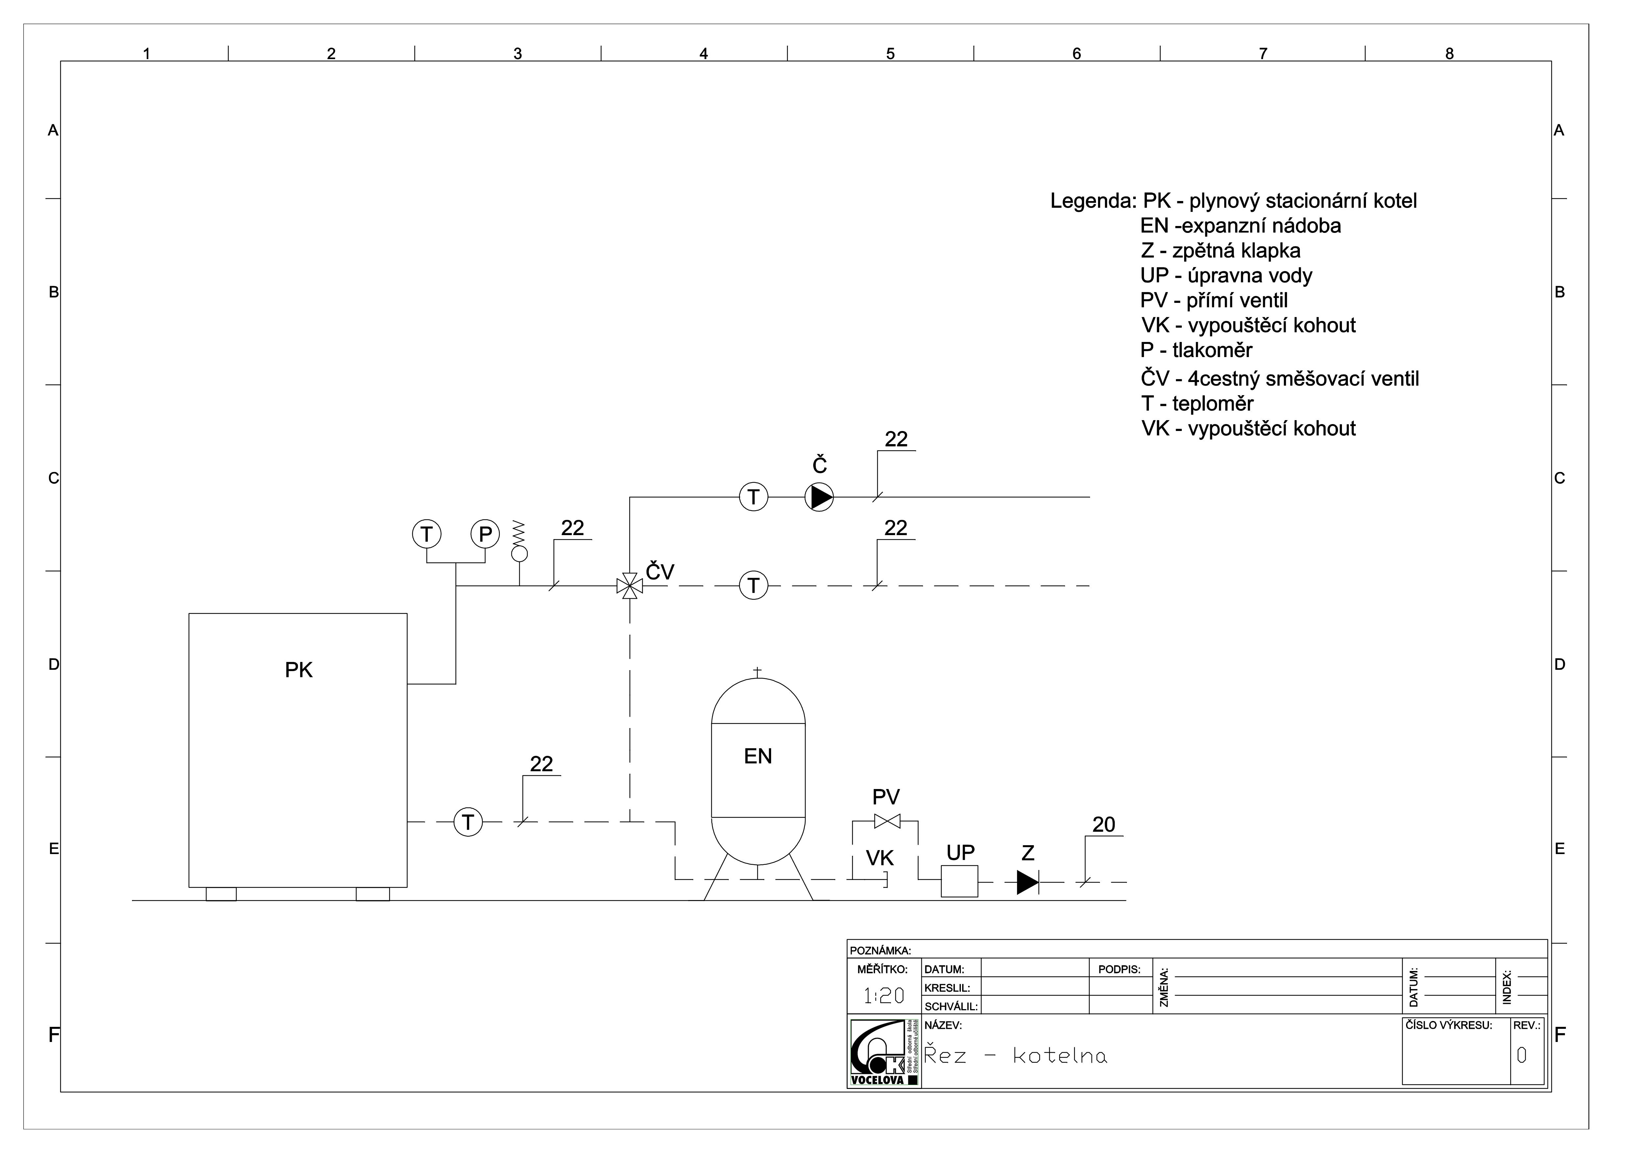

Resources:

http://www.potterton.co.uk/docs/Potterton_Promax_HE_Floor_Standing_Boiler_User_Guide.pdf
http://www.potterton.co.uk/docs/Potterton_Promax_HE_Floor_Standing_Boiler_User_Guide.pdf
http://www.baxi.co.uk/docs/Userinstructions.pdf
http://EzineArticles.com/3196387
http://mastertherm.co.uk/heat-pumps-residential-use/how-does-heat-pump-work
http://www.mastertherm.cz/princip-tepelneho-cerpadla

