

PROJEKT SONDA

TOPIC: TECHNICAL DOCUMENTATION
FOR STUDENTS OF AUTOMOTIVE INDUSTRY


Střední odborná škola a Střední odborné učiliště,
Vocelova 1338, 500 02 Hradec Králové
Vocelova 1338, 500 02 Hradec Králové, tel: 495212861, fax: 495212770, http: www.sosasou-vocelova.cz

Technical documentation and drawings – ENGINE – User guide

☺Discuss:

What is technical documentation?

What is a manual?

Why do we need manuals?

Which information do we find there?

☼ Learn:

Technical documentation
= refers to any type of documentation that describes handling, functionality, construction and use of a technical product.
Documentation may include:
- Warranty terms and conditions
- Assembly manual
- User guide

Assembly manual
= means instructions

Manual consist of:
- place of installation and clearances
- dimensions
- outputs/ inputs
- operating conditions

User guide includes:
- operating
- warnings
- trouble shooting
- services and contacts

Technical documentation and drawings – ENGINE – DRAWINGS

☺Discuss:

What is technical drawing?

Which information does a technical drawing include?

What can you see in the drawing?
Which information can you read from the drawing?

☼ Learn:

Technical drawing
= clearly defines requirements for appliances, includes the drawing of picture and graphical language that communicates ideas and information It communicates all needed information from the engineer to the workers who will make it.

It includes following information:
- Geometry – the shape of the object; views from various angles, such as front, top, side, etc.
- Dimensions – the size of the object in accepted units.
- Material – represents what the item is made of.

THE ENGINE

- The main part is a cylinder
- The cars usually need four or more cylinders
- Inside the cylinder there is a piston, which is free to move up and down the cylinder
- It is connected to a crankshaft by a connecting rod.
- At the top of the cylinder there is an air-intake valve, a fuel – injection valve, an exhaust valve, and a spark plug.
- A spark plug ignites the mixture of fuel and air
- The resulting explosion pushes the piston down the cylinder and the burnt gases leave the cylinder through the exhaust valve

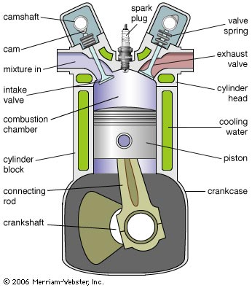

There are four engine cycles: INTAKE, COMPRESSION, POWER, EXHAUST

INTAKE stroke: on the intake or induction stroke of the piston, the piston descends from the top of the cylinder to the bottom of the cylinder, reducing the pressure inside the cylinder. A mixture of fuel and air, or just air in a diesel engine, is forced by atmospheric (or greater) pressure into the cylinder through the intake port. The intake valve(s) then close. The volume of air/fuel mixture that is drawn into the cylinder, relative to the volume of the cylinder is called, the volumetric efficiency of the engine.

COMPRESSION stroke: with both intake and exhaust valves closed, the piston returns to the top of the cylinder compressing the air, or fuel-air mixture into the combustion chamber of the cylinder head.

POWER stroke: this is the start of the second revolution of the engine. While the piston is close to Top Dead Centre, the compressed air–fuel mixture in a gasoline engine is ignited, usually by a spark plug, or fuel is injected into the diesel engine, which ignites due to the heat generated in the air during the compression stroke. The resulting massive pressure from the combustion of the compressed fuel-air mixture forces the piston back down toward bottom dead centre.

EXHAUST stroke: during the exhaust stroke, the piston once again returns to top dead centre while the exhaust valve is open. This action evacuates the burnt products of combustion from the cylinder by expelling the spent fuel-air mixture out through the exhaust valve(s).

1st phase - INTAKE: The mixture of air and fuel is drawn into the cylinder.

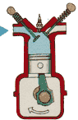

- The intake valve is open
- The exhaust valve is closed
- The piston descends from the top of the cylinder to the bottom of the cylinder

2nd phase - COMPRESSION stroke: The mixture is compressed – the pressure and temperature are increasing.

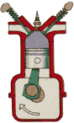

- The valves are closed
- The piston returns to the top of the cylinder

3rd phase - POWER stroke: The mixture is ignited. The piston is pushed down by the burnt products.

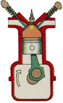

- The valves are closed
- The piston descends from the top of the cylinder to the bottom of the cylinder

4th phase - EXHAUST stroke: This action evacuates the burnt products of combustion from the cylinder.

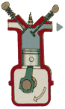

- The exhaust valve is open
- The intake valve is closed
- The piston returns to the top of the cylinder

- Describe the basic parts of engine

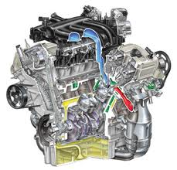

- Which phases of engine do you know? Describe them and label the pictures.

- Engine materials
Link the engine parts with the materials and processes.

cylinders cast iron
piston hard steel
oil sump hard aluminium
oil filter cover forged steel
camshaft plastic
cylinder head light aluminium alloy
compression rings normal aluminium
connection rods aluminium alloy with a graphite coating
engine block cast iron

